**Suggested Reading:** XAFS Techniques for Catalysts, Nanomaterials, and Surfaces (Chapter 8) [2]

**Vocabulary Words:**

**Dispersive:** To spread or to scatter. Dispersive optics often involve spreading out a focused beam of light in some way.

**Polychromator:** An optical device which disperses a single light beam composed of multiple wavelengths into multiple beams, each composed of a single wavelength. Some common examples include a prism or a diffraction grating.

**Spot size:** A measure of the cross section of the x-ray beam. For many experimental purposes it is often ideal to have a small spot size, especially for dispersive XAFS.

**Exercise:**  There are roughly 60 X-ray and vacuum ultraviolet (VUV) light sources all over the world. Below is a diagram for the ones contained in the America’s. Fill the bubbles with the numbers that correspond to the light source located in each area.

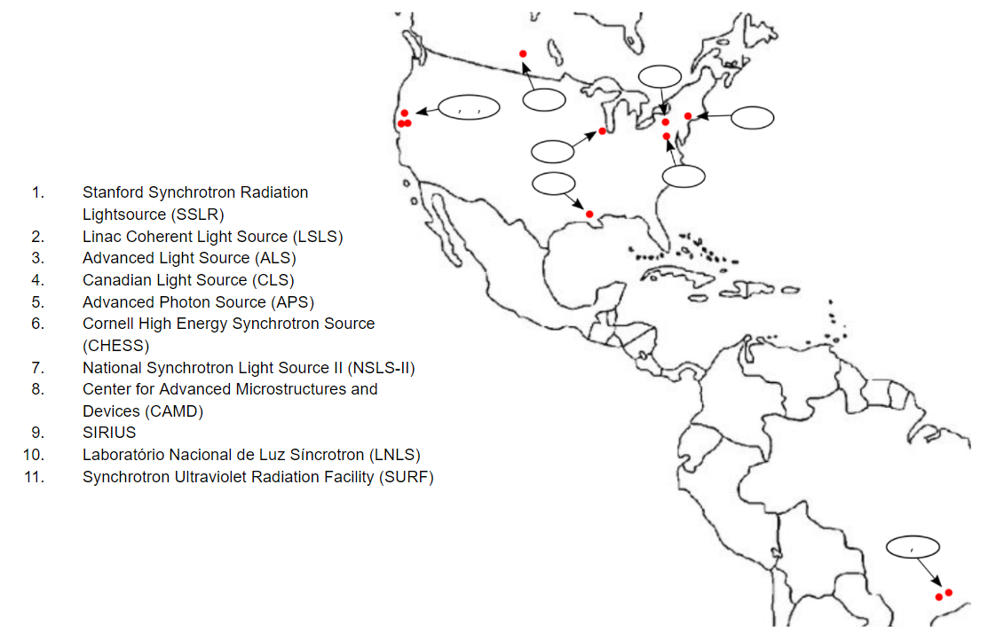

1. Dispersive XAFS Basics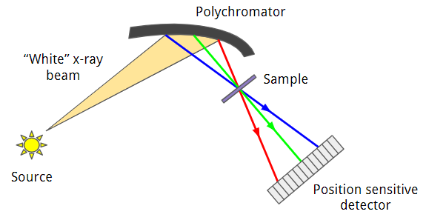
2. Above is a depiction of a dispersive XAFS experimental setup. Rank, in terms of the energy of the x-rays being reflected, the red, green, and blue lines. (Hint: Consider the bragg angles at which they are being reflected)

Blue, green, red

1. Below on the left is a graph of the normalized mux as a function of energy for the V metal K edge, taken by scanning over different x-ray energies at a standard synchrotron lightsource. Assume the same experiment was performed using a dispersive experimental setup. Draw (roughly) the mux XAFS spectra on the empty graph on the right as a function of pixel position instead of energy. What does this demonstrate about the relationship between pixel position and x-ray energy in the dispersive setup?

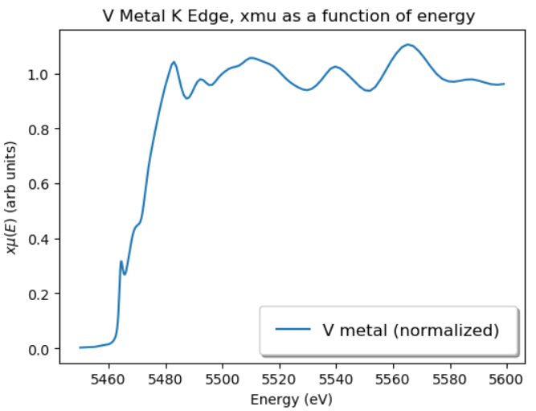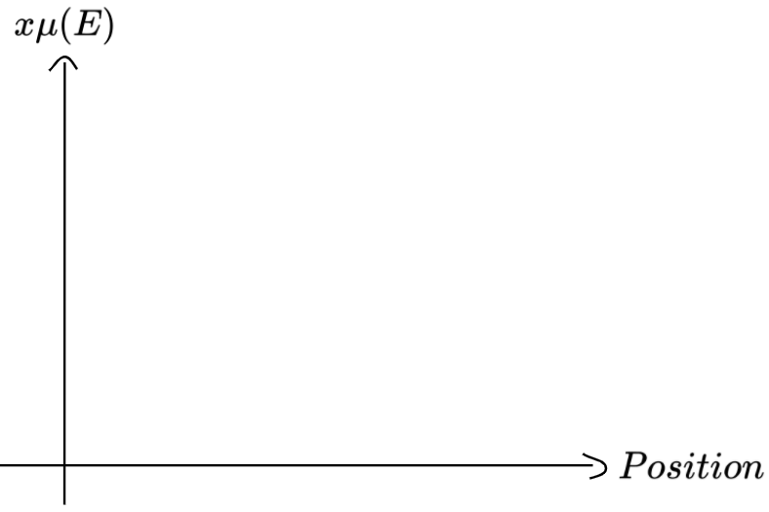

The graph of mux vs position will be exactly the same as the mux vs energy graph (at least in the ideal limit). This demonstrates that position and energy are directly correlated in this experimental setup.

1. These experiments require that the incoming “white” x-ray beam has a sufficient energy bandwidth to cover the entire EXAFS spectrum. Based on what we discussed in the Synchrotron Magnets and Beamline Optics Section, what kinds of magnets provide a large enough horizontal divergence? Why?

Bend magnets and wigglers. Undulators tend to produce brilliant radiation near particular frequencies which are correlated with the periodicity of the magnets in the undulator. Wigglers and bend magnets however produce their radiation more or less continuously over a large energy range, at least when compared to undulators. This makes both of them decently well suited for dispersive XAFS measurements given that the “white” x-ray beam can easily cover the energy bandwidth of the EXAFS spectrum of interest. Undulators *can* be used but require additional optics to induce some horizontal divergence in the radiation of the beam.

1. What are some of the main advantages of the dispersive approach over conventional means of measuring the XAFS spectrum?

Dispersive XAFS have the unique attribute of being sensitive to time-dependent phenomena. If a researcher wants to the XAFS spectrum as a reaction is occurring, dispersive XAFS allows them to watch how the entire XAFS spectrum changes simultaneously, which is ideal for reactions which occur on short time scales. Additionally, because there are no moving parts, dispersive XAFS are physically more stable which greatly reduces the systematic noise. Finally, having the polychromatic x-ray beam converge on a small focal point introduces a large amount of flux into a small area centered on the sample.

1. Limitations
2. Why might the scattering of x-rays at small angles be problematic for dispersive XAFS measurements? What kinds of samples does this affect the most? (Hint: Consider particle size)

X-rays that scatter at small angles may end up in the region of other x-ray energies on the position sensitive detector. This can end up degrading the energy resolution, broadening features in the fine structure [1]. This effect is most prevalent in powder samples, as there are often many small single crystal particles within the powder, all at different orientations. This will inevitably lead to more x-rays scattering at small angles, which have the potential to contaminate the signal of adjacent x-ray beams.

1. Given the dispersive experimental setup, it is usually infeasible to measure the intensity of each portion of the reflected x-ray beam before it interacts with the sample. Instead the $I_{o}$ measurement is done by the position sensitive detector before the sample is placed at the focal point. What potential drawbacks does this impose?

The incident beam intensity may fluctuate during the $I_{T}$ measurement due to x-ray beam instabilities which lead to normalization problems. Usually this is not an issue for regular transmission mode experiments as the incident intensity is measured at all times prior to interacting with the sample, but this is often impossible for the dispersive experimental setup.

1. Given that TEY and Fluorescence mode are reliant upon the de-excitation process, why is dispersive XAFS ill suited for these modes?

There is no way to know which fluorescence photons and Auger electrons are coming from which absorption events in the material. Because the sample is irradiated with x-rays of different energies simultaneously, it is impossible to distinguish the fluorescence signal or TEY signal changes with energy.

1. One of the advantages of doing dispersive XAFS measurements is the small spot size at the focal point. Why is this small spot size for the focal point important?

The small spot size means that you are effectively having all of your x-rays interact with the same volume of sample, which is important for ensuring that the absorption takes place in a sufficiently homogenous environment. Additionally, the small spot size is ideal for in situ studies of samples that exist in unique environments. It is often easier to create a region of incredibly high pressure or temperature in a small 1x1 millimeter space than it is over a larger area.

1. However this is limited by the variation of the Bragg angle as a function of penetration depth, errors in the curvature of the polychromator, and the inherent Darwin width of Bragg diffraction. In particular the negative effects of the Darwin width become more apparent at higher energy, limiting the accessible energy range of dispersive XAFS with this geometry. How might the geometry of the polychromator be changed to avoid the issues with the Darwin width at high energy?

The polychromator could be switched to a Laue geometry.

1. In general, the time scale at which dispersive XAFS experiments occur can be on the order of minutes to milliseconds depending on the needs of the experiment. In some cases, microsecond or lower resolutions may be required. At this time scale, why is it important to consider the electron bunches within the synchrotron?

The radiation produced from a synchrotron is dependent on a finite number of electron bunches. When the time scale of the detection is on the scale of the time scale of the radiation being emitted, it can no longer be assumed that the x-ray beam is at a constant intensity when it interacts with the sample. Therefore, the measurement of $I_{o}$ and $I_{T}$ must be calibrated such that they are being recorded at intervals corresponding to radiation pulses from the synchrotron.

III. Applications

1. Given your understanding of the time resolving capabilities of dispersive XAFS, give an example use case in which this technique would provide a unique advantage.

The most prominent application of dispersive XAFS is for catalysis studies, in which some chemical reaction is taking place on the order of minutes to milliseconds. A simple example would be an oxidation reaction, where the XANES spectrum might be used to sample how much of a species has reacted. The key point is that in situ *operando* investigations of chemical reactions are made much easier by the dispersive XAFS approach.

1. One technique for examining the dynamics of a system is through pump-probe XAS spectroscopy, where a system is first perturbed using a laser (pumping) and then the XAFS spectra is recorded (probe). What advantage would a dispersive XAFS approach give over a traditional transmission mode setup?

Because the dispersive setup allows the entire XAFS spectra to be captured in a single shot, the time-slicing method required in a traditional setup can be avoided. Not only is this significantly faster, but it avoids the problem of having to wait for the sample to relax back down to a ground state before it can be pumped again. Additionally, some samples can only undergo the pumping process a limited number of times before being destroyed. This means that the sample must be swapped out in between time-slices, which can cause issues with reproducibility. The dispersive XAFS approach avoids this issue entirely, because even if a sample is destroyed after the very first pumping, the entire spectrum is recorded simultaneously as it undergoes any dynamic processes.

Citations:

[1] Pascarelli, S., et al. “Turbo-XAS: Dispersive XAS Using Sequential Acquisition.” *Journal of Synchrotron Radiation*, vol. 6, no. 5, 1999, pp. 1044–1050., doi:10.1107/s0909049599004513.

[2] Iwasawa, Yasuhiro, et al. *XAFS Techniques for Catalysts, Nanomaterials, and Surfaces*. Springer International Publishing, 2018.